**Name: Trần Hữu Đạt MSSV: 522H0081**

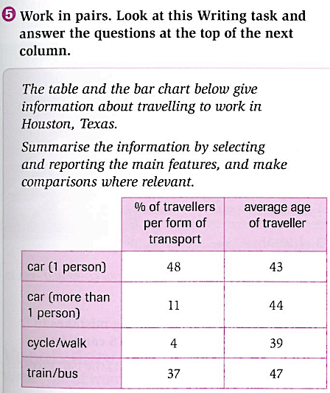

|  |  |
| --- | --- |
|  |  |

The table gives information about travelling to work in Houston, Texas and the bar chart makes information about the amount of CO2 emissions which from different forms of transport.

According to the table, the most common mode of transportation to travel in Houston is by car, with 48% of commuters traveling alone and 11% carpooling. Moreover, cycle only 4% travellers and 37% took a bus or train. The average age of car traveling alone and carpooling being 43 and 44 years old, respectively. The oldest age for using the bus or train was 47 years old, while the youngest age for cycling or walking was 39.

The bar chart shows the CO2 emissions per person per kilometer produced by different forms of transport. Walking and cycling produce no CO2 emissions, while taking the bus or train results in the lowest emissions. Furthermore, four people in the car, produces over 0.05 kilograms of CO2 emissions. However, driving alone in a car produces the highest emissions of under 0.35 kilograms.

In conclusion, the use of private transport was more dominant than the use of public transport but using public transport emitted fewer emissions private transport.